Principles
of
Social Teaching
End Poverty, Promote Justice, Uphold dignity.
Love of God, Love of neighbour

The Principles of Social Justice promote a vision of a just society that is grounded in biblical revelation, the teachings of the leaders of the early Church, and the wisdom gathered from experience by the Christian community as it has responded to social justice through history. Social Teaching covers all spheres of life – economic, political, personal and spiritual.
At its core is the value of human dignity which provides people with the capacity to develop fully.
I have come that you may have life and have it to the full. (John 10:10)
In this paper we will look at six principles of Social Teaching:
- The Common Good
- The Dignity of the Human Person
- Preferential Option for the Poor
- Solidarity
- Stewardship of Creation
- Subsidiarity and Participation
Rights and Responsibilities
The protection of human dignity is the foundation upon which an understanding of rights and responsibilities rests. The human person, made in God’s image and likeness, is born into a community of relationships and is social by nature. Rights and responsibilities are seen as the demands of upholding and defending human dignity in the social, economic and political spheres.
Rights begin with the most fundamental of rights, the right to life and include the right to those things necessary for basic human survival. The responsibilities begin with responsibilities to one another, to one’s family and to the larger society.

- The Common Good
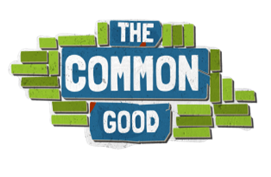
The collection of social conditions that make it possible for each social group and all their individual members to achieve their potential.
Each Person is a member of society. It is not just certain individuals but all people who are called to further the development of human society as a whole. The principle of the common good also emphasises that we are connected with other people.
The common good is understood as the collection of social conditions that make it possible for each social group and all of their individual members to achieve their potential. It means that each social group must take account of the rights and aspirations of other groups, and of the well-being of the whole human family. The rights and duties of individuals and groups must be harmonised under the common good.
This principle takes the issue of poverty beyond charitable acts and into the questioning and challenging of social values and structures. It requires that the poor and marginalised should be the focus of concern.
The concept of the common good dissolves the tension between selfishness and unselfishness, as it is in everyone’s interest to build up the common good by each person contributing to it. Those who serve others in this way automatically serve themselves.

- Dignity of the Human Person
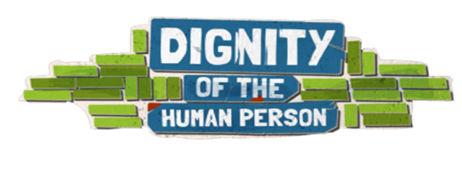
Each member of the human family is equal in dignity and has equal rights because we are all children of the one God.
Each person possesses a basic dignity that comes from God, not from any human quality or accomplishment, not from race or gender or economic status.
Human dignity is the starting point and central concern of Christian thinking about human rights.
Each person is created in the image and likeness of God and so has an inalienable, transcendent God-given dignity. It follows that each member of the human family is equal in dignity and has equal rights because we are all children of the one God. We are sisters and brothers to each other.
We understand God to be a trinity of persons and so we see the image of God reflected not only in individuals, but also in communities. Together in community we bear the image of our God whose very nature is communal.
Christian tradition is opposed to anything that is opposed to life itself, or that violates the integrity of the human person, and anything that insults human dignity. Human rights are the things due to us simply because we are human beings, they are the claims made by human dignity.

- Preferential Option for the Poor
How societies treat their most vulnerable members, the poor, must have an urgent moral claim on the conscience of a nation.
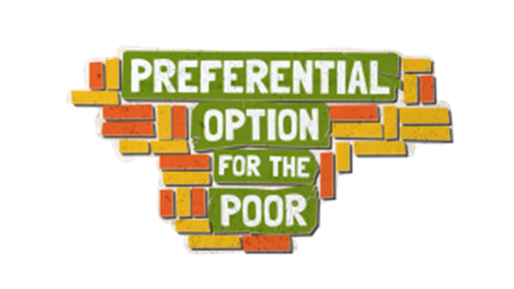
You are not making a gift of what is yours to the poor, but you are giving them back what is theirs. The earth belongs to everyone not to the rich.
This preferential option for the poor and vulnerable includes all who are marginalized in society, including unborn children, persons with disabilities, the elderly and terminally ill, and victims of injustice and oppression.
How societies treat their most vulnerable members, the poor, must have an urgent moral claim on the conscience of a nation. We are called to look at public policy decision in terms of how they affect the poor. Caring for the poor is everyone’s responsibility. Preferential care should be shown to poor and vulnerable people, whose needs and rights are given special attention in God’s eyes.
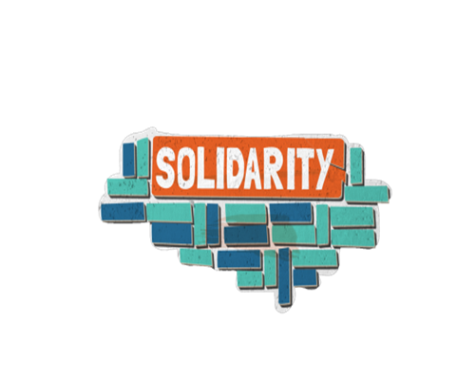
- Solidarity
An essential stance of faith and a feature of moral consciousness recognising that we belong to one human family.
Solidarity is a firm and persevering determination to commit oneself to the common good; that is to say, to the good of all and of each individual, because we are all really responsible for all.
It is not about a vague sort of compassion or shallow distress at others’ misfortune, but involves a determination to commit oneself to working for change so that everyone will be able to reach their potential. It is about respect for and the promotion of the dignity and rights of our sisters and brothers.
Solidarity is an essential stance of faith and a feature of moral consciousness recognizing that we belong to one human family. One demand of such membership is the responsibility to participate in the building up of community and the fostering of unity. Solidarity invites such participation and awareness at all levels and across all borders. We have mutual obligations to promote the rights and development of all people across communities, nations, and the world, irrespective of national boundaries. Solidarity is a way of “being with” our sisters and our brothers around the globe.

- Stewardship of Creation
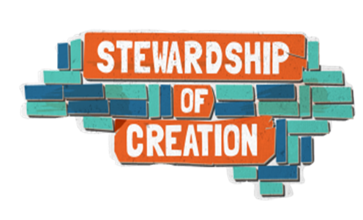
We must all respect, care for and share the resources of the earth, which are vital for people’s common good.
The way we live and the choices we make affect the lives of others, not only human life, in fact, but also the other forms of life found on earth.
How do I show respect for Creation? We must all respect, care for and share the resources of the earth, which are vital for the common good of people. Care for animals and the environment is a common and universal duty, and changes in the environment call for a change of mentality and the adoption of new lifestyles. Our duty is to seek to promote care for the earth and its resources.

- Subsidiarity and Participation
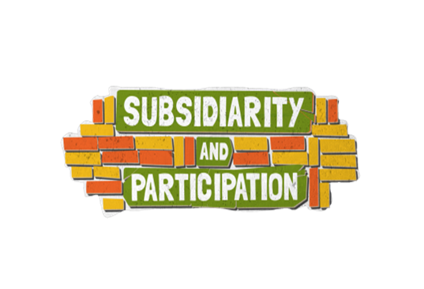
People have both a right and a duty to participate in those decisions that most directly affect them.
The characteristic implication of subsidiarity is participation, which is expressed essentially in a series of activities by means of which the citizen contributes to the full life of the civil community to which he/she belongs.
The principle of subsidiarity places responsibility as close as possible to the grassroots. The people or groups most directly affected by a decision or policy should have a key decision-making role. They should only be interfered with in order to support them in cases of need, and to help coordinate their activities with the activities of the rest of society with a view to the common good.
Because of their intelligence and free will, people have both a right and a duty to participate in those decisions that most directly affect them. They are actively to shape their own destiny rather than simply accept the decisions of others.
This right to participate belongs not only to individuals but also to groups and communities.
One way to reflect on participation is to ask: who wins? Who loses? Who decides?

Six Principles of Social Teaching

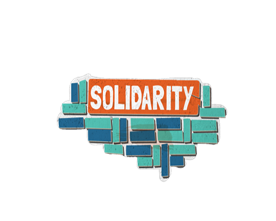 | 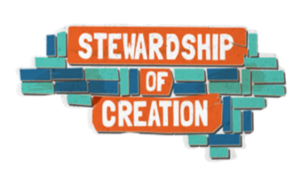 | 