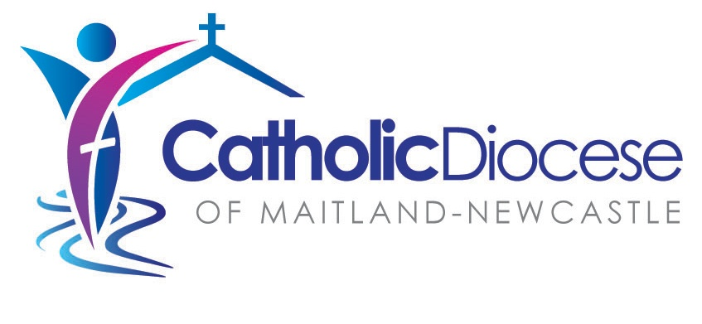

Pastoral Guidance
for the Preparation and Celebration
of the Sacrament of Confirmation

Guidelines, Procedures, Resources

Appendix 1 – COVID safe version
Presentation of Symbols
and
Appendix 2 – Simplified Baptismal Promises

May 2023

Alternate Rite: Presentation of Symbols
The following ritual is for use in the Introductory Rite in The Conferral of Confirmation without Mass.
It is presented here with the same formatting as the master copy templates and so can be copied and pasted straight into your master copy.
The focus of the following outline of the Introductory Rite is the fourth element, the Presentation of Symbols. Preparation for this element begins in the Entrance Procession. That is why the entire Introductory Rite is included here. It is to be adapted by the community to suit its circumstances.
Green text is instruction for those preparing the liturgy and is to be deleted from the completed Master Copy.

Gathering Hymn
The Paschal Candle is in position and lit.
When those to be confirmed are assembled with their sponsors and parents, and the whole gathering of the faithful, the gathering hymn begins and the liturgical procession moves to the sanctuary as follows: cross bearer, person carrying the Oil of Chrism, person carrying the Book of the Gospels with clergy following as usual.
Upon reaching the sanctuary, those carrying symbols move to stand in the designated place. The other ministers make the usual reverence to the altar and move to their position.
The bishop gives his mitre and crozier to the servers.
Insert words to hymn here.
Greeting
Bishop: In the name of the Father, and of the Son, and of the Holy Spirit.
All: Amen.
Bishop: Peace be with you.
All: And with your spirit.

Introduction
The bishop introduces the celebration.
Presentation of Symbols Please be seated
The reader moves to the lectern [Not the Ambo]. When the reader is in position, while remaining at the chair, the bishop continues as follows.
Presider: We gather tonight as God’s holy people, his disciples who ‘put on Christ’ at baptism.
The Light of Christ
Gesturing towards the Paschal Candle the reader continues.
Reader: The Paschal Candle shines brightly reminding us that at baptism we were enlightened by Christ, promising to keep the flame of faith alive in our hearts.
Christ our light.
All: Help us to walk always as children of the light.
The Cross
The cross bearer holds the cross aloft as the following dialogue takes place.
Reader: At baptism we were claimed for Christ the priest, our parents and godparents marking us with the sign of the cross.
Christ our strength.
All: Help us to love as you love us.
The cross bearer places the cross in its usual place and returns to her/his place. The ritual continues when this action is complete.
The Word of God
The bearer of the Book of the Gospels holds it aloft as the following dialogue takes place.
Reader: At baptism the priest prayed that our ears would be open to receive the Word of God and our mouth to proclaim it.
Christ our word of life.
All: Help us to listen to your word and pattern our lives on the Gospel.
The person places it on the altar, steps back and bows and returns to his/her place. The ritual continues when this action is complete.
The Holy Chrism
The bearer of the Holy Chrism holds it aloft as the following dialogue takes place.
Reader: At baptism Christ anointed us with the oil of Chrism, so that, united with all God’s people, we would remain forever a member of Christ who was anointed Priest, Prophet and King.
Tonight in the sacrament of confirmation God will again pour out the Holy Spirit upon our candidates so they will become more like Christ.
Christ our saviour.
All: Help us to live as your disciples.
The person places the Chrism near the Paschal Candle and baptismal font. He/she returns to his/her place. The reader also returns to his/her place.

The Asperges – Rite for Sprinkling with Holy Water Please stand
The bishop moves to stand near the baptismal font. A server has the vessels to be filled with holy water.
Bishop: Dear friends, we come together to celebrate the sacrament of confirmation, an important step in the process of Christian Initiation.
May this baptismal water remind us of the promises we made at our baptism. As we use it in this sprinkling rite, let us, through the power of God’s Spirit, be healed of our brokenness and renewed in faithfulness and love.
The bishop takes water from the font and moves through the church sprinkling the community with baptismal water. Music or an appropriate refrain accompanies the ritual action.
Insert words to any refrain being used here.
Upon returning the bishop goes to the font, pours the remaining water in and then returns to the chair. When all is ready he continues.
Bishop: May almighty God have mercy on us,
forgive us our sins,
and bring us to everlasting life.
All: Amen.

Collect
Insert collect here.
Please be seated. The bishop receives his mitre from the server and puts it on.

‘Presentation of Symbols’ and Introduction to the Asperges: Local composition © Diocese of Maitland-Newcastle. All rights reserved. Used with permission within the Diocese of Maitland-Newcastle.

Appendix 2: Simplified Renewal of Baptismal Promises
It is strongly recommended that the Renewal of Baptismal promises from the Order of Confirmation be used. If there is a significant pastoral need the following slightly simplified version may be used.
The bishop continues using these or similar words.
Bishop: Boys and girls, your Christian Initiation began with your baptism. At that time your parents and godparents spoke in your name, promising to bring you up in the love of God and the faith of the Church.
A little earlier you stood when you were presented for confirmation – the next sacrament of initiation. This indicates that you are old enough to renew the promises made at your baptism. These promises remind us of the important elements of our faith that help us pattern our lives on the Gospel.
And so, before this faith community gathered to support you, I ask …
Bishop: Do you reject Satan and everything that is against God’s law of love?
Candidates: I do.
Bishop: Do you believe in God the Father who created everything in the heavens and on earth?
Candidates: I do.
Bishop: Do you believe in Jesus, God’s Son, whose mother was Mary?
Candidates: I do.
Bishop: Do you believe that Jesus died and rose from the dead and is with God the Father forever?
Candidates: I do.
Bishop: Do you believe in the Holy Spirit who fills you with the life of God and will be given to you in confirmation today?
Candidates: I do.
Bishop: Do you believe in the holy Catholic Church; in God’s forgiveness, and that God will raise up our bodies to live with him forever with the saints?
Candidates: I do.
Bishop: This is our faith.
This is the faith of the Church.
We are proud to profess it in Christ Jesus our Lord.
All: Amen.
Simplified Renewal of Baptismal Promises: Local composition © Diocese of Maitland-Newcastle. All rights reserved. Used with permission within the Diocese of Maitland-Newcastle.

