Online Service Desk User Guide
Human Resources

CONTENTS

1 HR Services Service Catalogue 2
2 HR Request 2
3 External Contact/Contractor Account Creation 4
4 Authority to Recruit 5
4.1 Vacancy Details 5
4.2 Action required 7
4.3 Position Details 8
4.4 Advertising Details 10
4.5 IT Hardware 10
4.6 Employment Details 11
4.7 Selection Panel 12
4.8 Approvals 12
4.9 Review and Submit 14
4.10 Approval Process 14
5 New Contract Request 14

HR Services Service Catalogue
Within the HR Services category in Service Catalogue you will find 6 forms that can be raised, each of these forms has its own required information and underlying lifecycle.

This document will guide you through raising and completing each form.
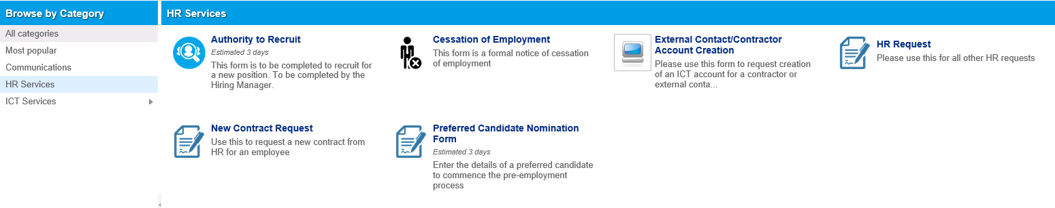

HR Request
This request is a very simple catch all form, if you are unable to find an HR form in the catalogue relating to what you require please use this general form.

The first field you are presented with is a drop down with all the different types of request you can make to HR.
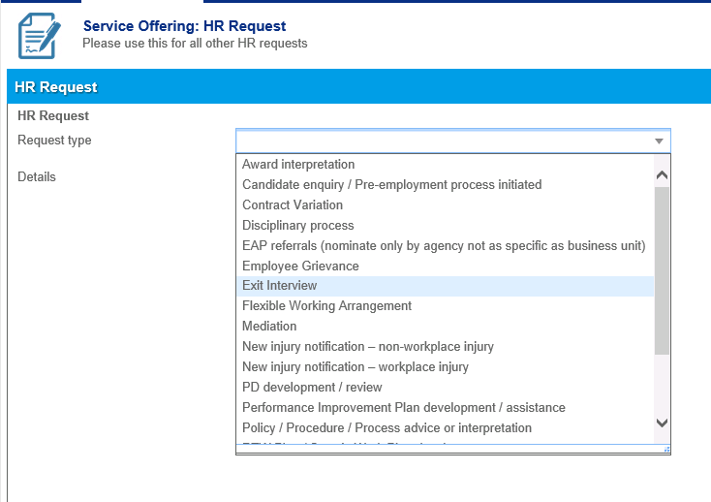
If you cannot find something relevant in the drop down you can choose “Other”.
Then simply fill out the details of the request you are making and submit.
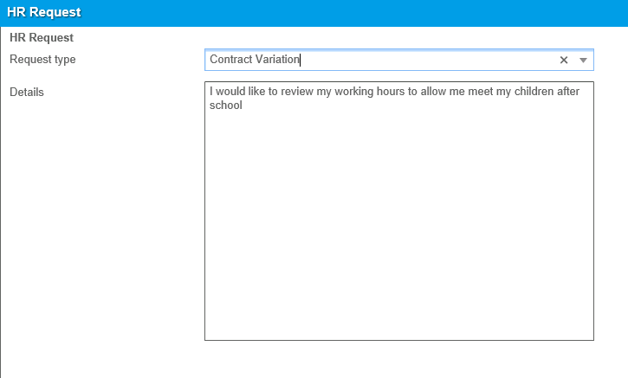

External Contact/Contractor Account Creation
If you have an external contact or contractor who will be working with us and requires IT access you will need to complete this form.
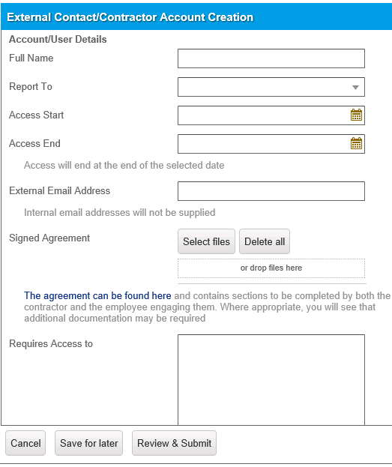

When completing this form please ensure you complete all the fields and have the external contractor sign the agreement and that upload to the form. It will be reviewed and if accepted, signed on behalf of the Diocese by In House Counsel.

Authority to Recruit
In order to initiate the process of hiring an employee you MUST first raise an Authority to Recruit form.
If you have not completed this form HR will NOT process any candidate nominations, new contract requests etc.

As this form is tied to our organisational structure and payroll system and has a lot of fields that could be confusing, the following instructions have been provided.

If there is no reference to a field in this document please try to fill it out as best you can.

Vacancy Details
In this section of the request the main thing to be aware of are the first 4 fields.
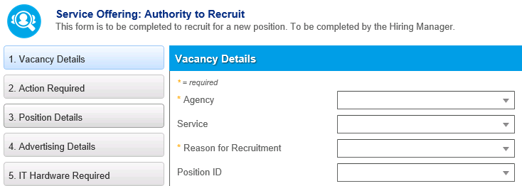

When you select an Agency you will see the options in the Service also change. Please see two examples below;
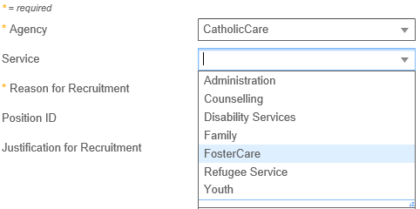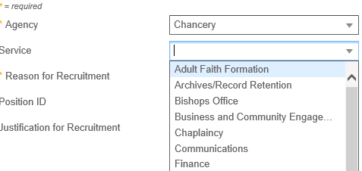

If you are aunsure of which Agency and Service to select please call HR and they can advise.

The next field is the Reason for Recruitment, if you select New Position the system will hide the Position ID field.
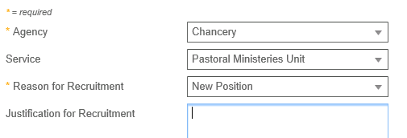
If you set the Reason to Vacant Position you will see the Position ID field remains in place.
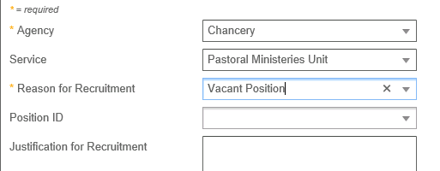
The Position ID field is filtered by the Agency and Service you have selected above.
If you cannot find the position you are recruiting for please try to change the Agency and Service and see if the position is referenced elsewhere.
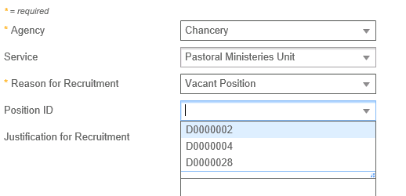

Action required
The first field in the Action Required section is the Job Description.
Whether this is a new position or an existing position please attach the job description to the form.
This can only be in .DOC or .DOCX format. The field not accept PDF’s
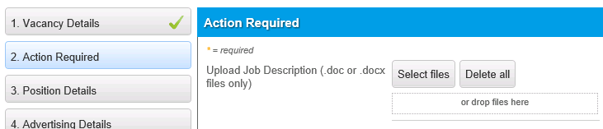
If you tick either of the bottom two checkboxes you will be prompted for further information
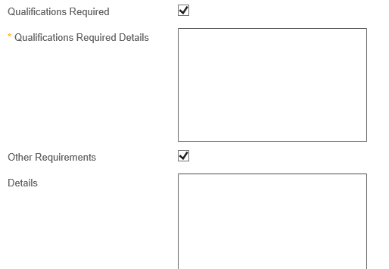

Position Details
If you have selected an existing position in the first section the Reports to Position will already be populated for you
If this is for a new position you will need to populate the field
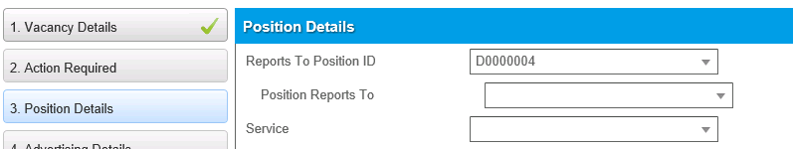

When you do so please select the Position Reports to person. This will be filtered by the field above.
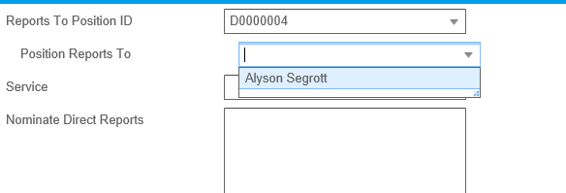
The Service should also populate automatically when you select the Reports to Position ID

Further down the same section you will see Employment Status and Term.
If you select Max Term in the Employment Status this will change the fields you need to complete.
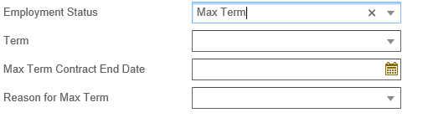
In Reason for Max Term if you select Other you will be presented with a box for further information.
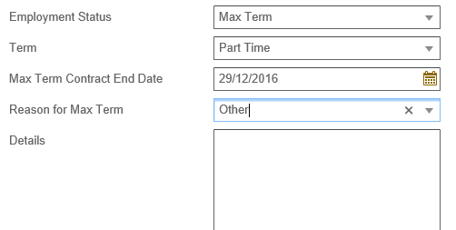

Advertising Details
If you only require the role to be advertised internally, select the Internally option in Advertise role. You will not be presented with any more options.
If, however, you need the role to be advertised externally to the Diocese then please select Internally & Externally.
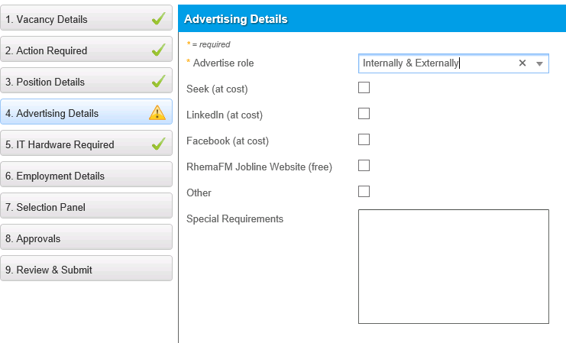
Please then select where you would like the Job to be advertised.

IT Hardware
When recruiting a new position the ICT Team need to know if equipment needs to be ordered so it can be delivered in time for the person to commence. Information provided in this section will be automatically provided to the ICT team to commence procurement.

If you do require the role to have hardware to be supplied please untick the “Hardware already in place” box.

In the new fields you will need to specify what IT hardware is required for the new starter.
As you select entries you will see the total cost as well as any ongoing IT maintenance fees are added up on the right hand side of the screen.
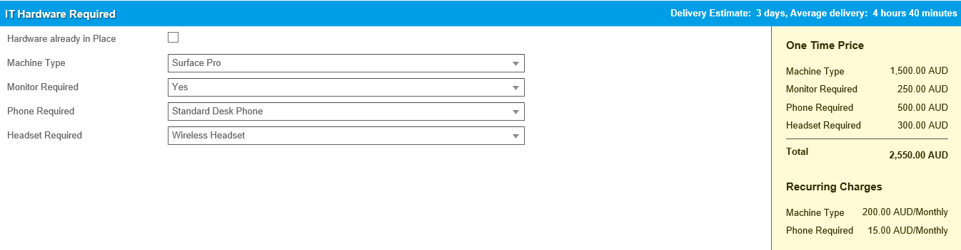

Employment Details
Within the Employment Details you will need to fill out the hours worked per fortnight as well as the days the position is required to work.
You will then get to the Coverage and pay section.
If you select anything other than “Award Free” in the Awards field you will need to complete the Classification Level or Grade.
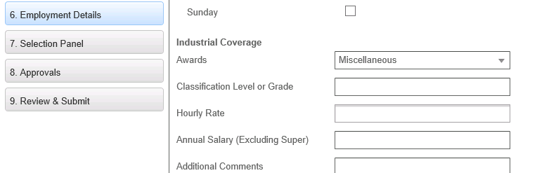
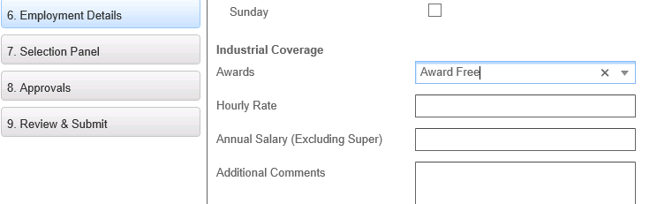

Similarly, the Hourly Rate and Annual Salary are linked. If you complete one, the other will be removed from view
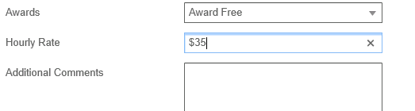
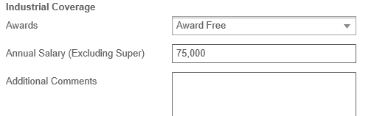

Selection Panel
When selecting Panel Members, you will be forced to select at least 2 people, please attempt to fill out as many as possible as this is more useful for HR.

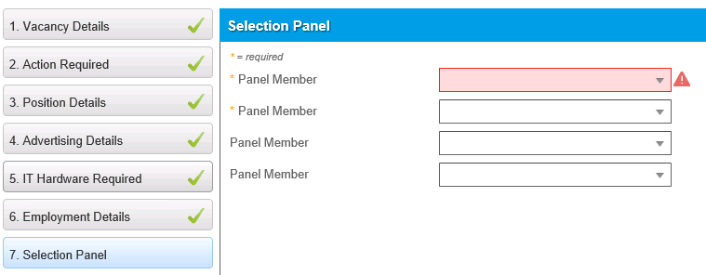

Approvals
Depending on the Agency, Service and Reason for Recruitment you select at the beginning of the form you will be shown different levels of approval that are required for the ATR.
Below you will see an ATR for a vacant position then a new position in the Chancery and the levels of approval you will need to complete.

Vacant position
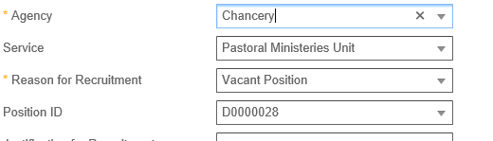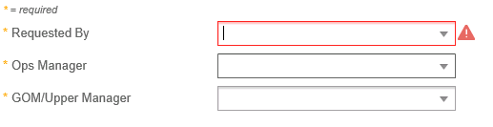
New Position
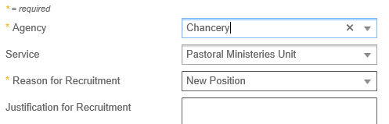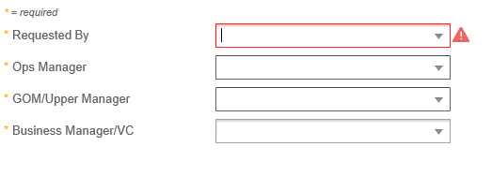

Below is a CatholicCare vacant vs new position and their approvals.

Vacant position
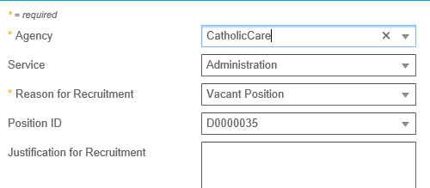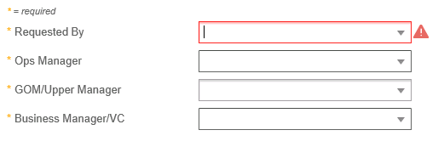

New position
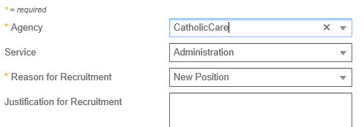

Review and Submit
Once all information has been complete you will need to Review the change, then submit it.

Approval Process
On submission the Authority to Recruit will be submitted for approval.
This process can be found in the attached document.

New Contract Request
If a new employee comes on board or there’s a variation to the conditions or role of an employee, a new contract is required. Use this form to request a new contract from the HR team.

Start by selecting the Reason for New Contract from the drop down list. If there’s been a new position, you will need to choose the approved Authority To Recruit (ATR) from the new field that appears. This list will only be populated by ATRs that were created by you (or where you were the delegate) and that have been approved. If you’re not sure who completed the ATR please call HR for assistance.
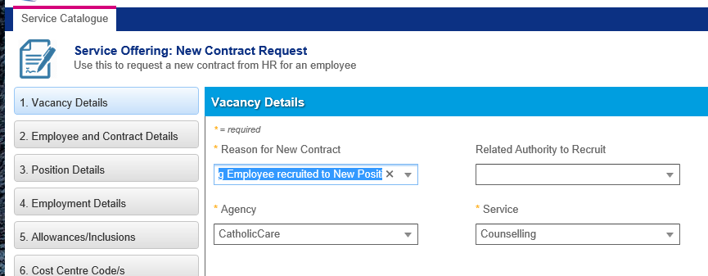

Complete all fields on the “Employee Details screen”. You can narrow the list of employees in the “Existing Employee” drop down list by typing the employee’s first name”

On the Position Details screen, if you have selected an ATR, most of these values will be completed. If you haven’t selected an ATR in the Vacancy Details screen, such as for a renewal of a max term contract, these details will need to be completed.

On the Employment Details screen please complete all fields

On the Allowances/Inclusions screen, please tick all relevant boxes

On the Cost Centre Code/s screen, please be sure to correctly enter all relevant cost codes to a percentage total of 100.

On the Days and Hours of Work screen, please complete all fields.
- The contracted hours cannot be greater than 80 per fortnight.
- If the second week is the same as the first week, you can tick the box to copy values down

On the ICT Access screen, please tick the box if the employee will require ICT access. This will enable additional fields that will be used to notify the ICT team of the new employee’s requirements. This page replaces the “New ICT User form” that was previously completed by a manager and provided to the ICT team. If you’re unsure about any of the fields on this screen, please contact the ICT team on 0249791129
- Mailbox Required – This is generally “Standard Mailbox”
- Shares/Distribution Groups
  - Please list the access requirements for shared folders and public folders, including as much information as possible.
  - Please list any email distribution groups that the person should be added to
- Please also identify a person in a similar role. This can assist the ICT team to gauge other configuration requirements.

On the Supporting Documentation screen, please upload all relevant documentation, especially those items marked with a *

On the approvals screen, please select the approvers appropriate for this contract request.
- Start by selecting the Requested By – this may be yourself, or your manager if you are completing the request on their behalf
- Then work backwards, selecting the highest required approver first then the one below. If you run out of people in the line from “Requested By”, simply add yourself for the lower approvals. This is especially relevant where the “Requested By” is quite senior. For example:
If Pamela was filling out a New Contract Request on behalf of Gary (GOM) for a new Operations Manager:
  - Pamela would enter Gary Christensen (GOM) in the “Requested By”
  - Helga Smit (Director) as the director
  - Adrian Hill (Business Manager) as the Business Manager
  - Gary Christensen (GOM) as the GOM
  - For the Ops Manager, Pamela could put herself.
- In this example, once submitted, the request would go first to Pamela, who can approve it right away, progressing it to the next approver in line, which would be Gary as the GOM.
On the Review and Submit page, please review all of your choices carefully. If you need more time to clarify something, click “Save for Later” and you will be able to return to the request at a later stage. If you are sure that all the information has been entered correctly, click Submit to submit the request.

Approvals
The Online Service Desk supports approvals in request workflows using votes. These workflows are generally linear, requiring each approver to cast their vote as “Approved” before moving up the chain.

When a request is sent for approval, the approver is notified via email and an item is added to their My Items section in Self Service. To cast their vote, they can either reply to the email, or they can click on the record in My Items section of self service. If a person is listed in multiple approval positions, they will receive additional voting notifications in turn.

Please note, the team processing a request (HR, Communications etc.) will always review the approval history to ensure that the approval process has been correctly followed before processing a request.

