Liturgy of the Hours
Cathedral (Short) Version – Evening Prayer
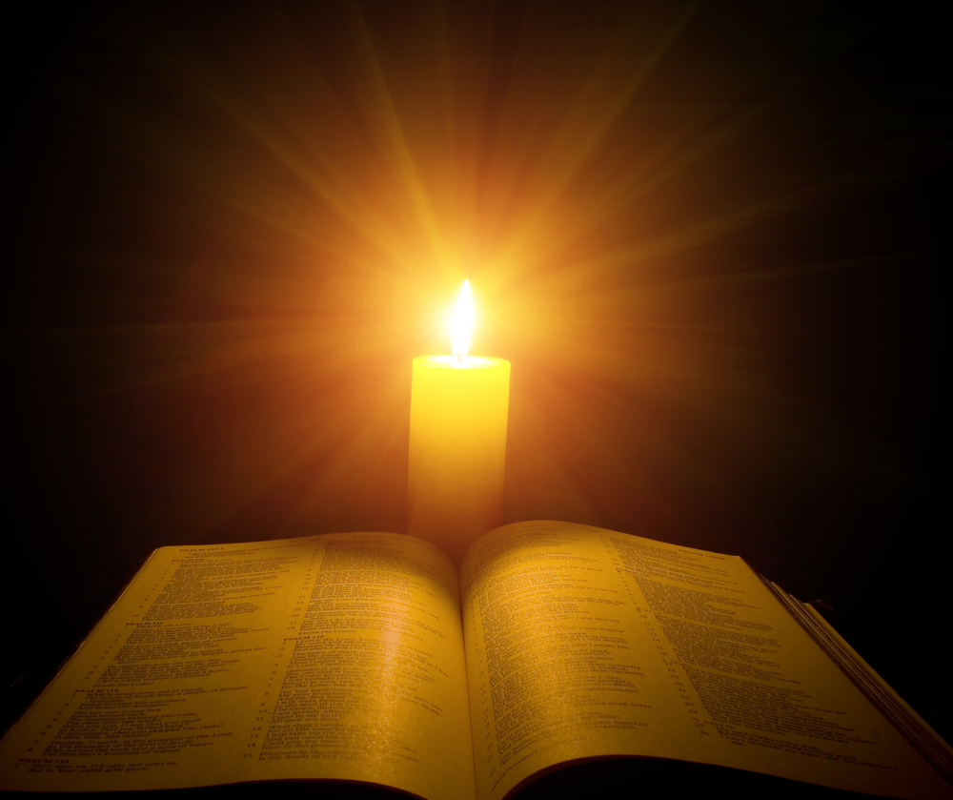
Outline and Sample Template
Twenty Eighth Week of Ordinary Time
Thursday Week 4
Cathedral (or Short) Version
The ‘Cathedral’ (or short) version of the Liturgy of the Hours, otherwise known as The Prayer of the Church has a more simple structure than the ‘Monastic’ version prayed by most clergy and Religious. The elements in blue form the foundation of this prayer and the shortest form it might take.
The ‘typical’ structure for the Cathedral version is outlined below. A sample template follows.
Morning Prayer | Evening Prayer
Introductory Rite
Introduction
Introductory Verse
Hymn
(appropriate to the hour and with copyright acknowledgement)
Psalmody
Psalm
Silent Prayer
Collect/Psalm Prayer
Word of God
Scripture Reading
Silent Reflection
Praise and Intercession
Gospel Canticle: Benedictus | Gospel Canticle: Magnifiat
Intercessions
Lord’s Prayer
Concluding Rite
Blessing
Dismissal

Like all liturgy, the Liturgy of the Hours involves various liturgical ministries including the Leader and a person to proclaim the scripture. Instructions to stand and sit may be used depending on the setting. They are most appropriate for a more formal celebration in the Church.

INTRODUCTORY RITE

For Evening Prayer it is appropriate to use at least one candle as a sign of the light of Christ that never fades. This may sit beside the scripture.

Introduction
The Leader may briefly introduce the prayer. Allow a brief silence after this before beginning.

Introductory Verse Please Stand
Leader: O God, come to our aid.
All make the sign of the cross.
All: God, make haste to help us.
Glory be to the Father, and the Son,
and the Holy Spirit,
as it was in the beginning
is now and ever shall be,
world without end. Amen.

Evening Hymn:
Choose an appropriate Evening hymn.

PSALMODY

One appropriate psalm is used, normally taken from the ‘Liturgy of the Hours’ for the day.

Psalm: 143 (144) Please be seated
Side 1: Bless the Lord my rock
who trains my arms for battle,
who prepares my hands for war.
Side 2: He is my love, my fortress;
He is my stronghold, my saviour,
My shield, my place of refuge.
He brings peoples under my rule.
Side 1: Lord what is man that you care for him,
mortal man that you keep him in mind;
man who is merely a breath
whose life fades like a shadow?
Side 2: Lower your heavens and come down;
touch the mountains; wreathe them in smoke.
Flash your lightnings; route the foe.
Shoot your arrows and put them to flight.
Side 1: Reach down from heaven and save me;
draw me out from the mighty waters,
from the hands of alien foes
whose mouths are filled with lies,
whose hands are raised in perjury.
Side 2: Glory be to the Father, and the Son, and the Holy Spirit,
as it was in the beginning, is now and ever shall be,
world without end. Amen.
Allow a brief pause for personal reflection.

Psalm Prayer Please stand
Leader: Let us pray.
Pause for silent prayer
May your grace, O Lord, we pray,
At all times go before us and follow after
And make us always determined
to carry out good works.
Through our Lord Jesus Christ your Son,
who lives and reigns with you and the Holy Spirit,
one God forever and ever.
All: Amen
Please be seated. Allow a brief period of silence before the Reading begins.

WORD OF GOD

Depending on the setting, the reading may be proclaimed from the Ambo, or from the reader’s place. Choose a brief reading which may come from the Liturgy of the Hours for the day and hour.

Scripture Reading: Col 1:23
Continue securely established and steadfast in the faith, without shifting from the hope promised by the gospel that you heard, which has been proclaimed to every creature under heaven.
Allow a time of silence for personal reflection. If appropriate people could share their reflections.

PRAISE AND INTERCESSION

Canticle of Mary (Magnificat) Please Stand
All make the sign of the cross as the first line of the Canticle is prayed.
Side 1: I acclaim the greatness of the Lord,
I delight in God, my Saviour
who regarded my humble state.
Truly from this day on
all ages will call me blest.
Side 2: For God, wonderful in power
has used that strength for me.
Holy the name of the Lord!
whose mercy embraces the faithful
one generation to the next.
Side 1: The mighty arm of God
scatters the proud in their conceit,
pulls tyrants from their thrones
and raises up the humble.
The Lord fills the starving
and lets the rich go hungry.
Side 2: God rescues lowly Israel,
recalling the promise of mercy,
the promise made to our ancestors,
to Abraham’s heirs for ever.
Side 1: Glory be to the Father …

Intercessions
The following Intercessions are an example. Depending on the setting, all intercessions might arise spontaneously from the community or could be taken from any suitable resource, including ‘The Liturgy of the Hours’; they may be read by one person as at Mass, or shared amongst the community.
Leader: The light shines out in the darkness and the darkness cannot overcome it. Let us thank our Lord for bringing God’s light to our lives.
All: Lord Jesus Christ, you are our light.
Word of God, you have brought the light of eternity to the darkened world: may it open the minds and hearts of all baptised. R.
Show your care for all who dedicate their lives to the service of others: may your grace inspire their actions and sustain them to the end. R.
Lord, you healed the paralytic and forgave him his sins: pardon all our guilt, and heal the wounds of our sins. R.
People follow the light to new knowledge and discovery: may they use your gifts to serve the whole human family, and so give glory to you. R.
Lead the dead from darkness into your own wonderful light; in your mercy show them the radiance of your glory. R.
Pause for spontaneous prayers.

Lord's Prayer
Leader: As sons and daughters of a loving God, we pray in the confident words of his Son:
All: Our Father …

CONCLUDING RITE

Concluding Prayer
Leader: Listen favourably to our evening prayer, Lord,
and grant that as we follow your Son’s example,
we may, by perseverance,
yield a harvest of good works.
We make our prayer through Christ our Lord.
All: Amen.

Blessing
A blessing may conclude the liturgy. The flowing is from the ‘Liturgy of the Hours’.
Leader: May the Lord bless us
protect us from evil
and bring us to everlasting life.
All: Amen.

Acknowledgements
Excerpts from Evening Prayer are taken from The Divine Office, © 1974, the hierarchies of Australia, England and Wales, Ireland. All rights reserved.
Psalm Prayer taken from the English translation and chants of The Roman Missal © 2010, International Commission on English in the Liturgy Corporation. All rights reserved.
The Scripture quotations contained herein are from The Jerusalem Bible © 1966 by Darton, Longman & Todd Ltd and Doubleday and Company Ltd, and used with permission of the publishers.

